lab 1

In this lab work you must develop a computer application to collect and display information about customers and products for the Bock Repair Parts Sales, LLC.

**Design Requirements**. Develop a form that is similar to the one shown below. Your form may have minor differences. The form enables the application user to enter information about customers and to select the type of vehicle and color to use when displaying information. There are two output TextBox controls and three PictureBox controls.

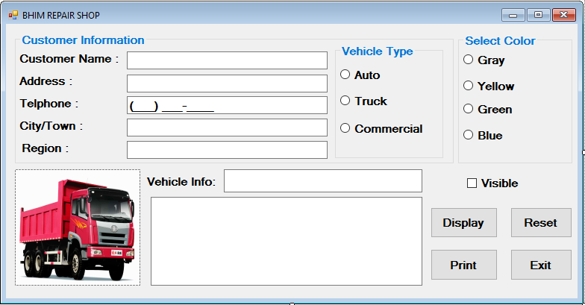

Form Design.

Name all controls following the naming standard taught during class meetings.

Set the appropriate property to display the form's title bar as shown in the figure to display the words Bock Repair Parts along with your name, for example: Bock Repair Parts - by John Smith.

Set the appropriate property to cause the form to startup centered in the display monitor.

**Customer Information GroupBox.**

Add a GroupBox control as shown. Set the appropriate property so that the GroupBox displays the words Customer Information as shown in the figure.

Add three Label controls as shown for use as prompts to display the words: Customer Name:, Address:, and City/Town:, Address:, Telphone: and Region.

Add TextBox controls to enable the application user to enter the customer name, address, city, Telphone and region. Give each TextBox an appropriate name.

Add a MaskedTextBox control so the application user can enter the Telphone. Give the masked textbox an appropriate name. Set the appropriate property for the MaskedTextBox control so that the control displays a 10 digit telephone mask.

Add a label that displays the words Vehicle Info: and two read-only TextBox controls as shown – these TextBox controls will display output as described later in this document. Give each TextBox an appropriate name.

Set the appropriate property so that each TextBox can only be used to display output – the application user cannot type into either TextBox.

Set the appropriate property so that the Tab key does not tab to either of these TextBox controls.

Set the appropriate property of the second TextBox so that it can display multiple lines of output (identified as a Multiline TextBox in the figure).

Add a CheckBox control as shown. The control should be checked when the project initially starts up.

Vehicle Type GroupBox.

· Add a GroupBox control as shown inside of the Customer Information GroupBox.

· Set the appropriate property so that the GroupBox displays the words Vehicle Type as shown in the figure.

· Add three RadioButton controls in this GroupBox and set the appropriate property to display the words Auto, Truck and Commercial.

· The auto RadioButton control should be the checked as the default on form startup.

· Selecting one of these RadioButton controls should cause two things to happen:

o Display information about the selected vehicle type in the vehicle info TextBox.

o Display a picture of the selected vehicle in a PictureBox control.

· The information to display in the read-only vehicle info TextBox control and PictureBox controls is given in this table.

Radio Button

Color GroupBox.

Add a GroupBox control and set the appropriate property so that the GroupBox displays the word Select Color as shown in the figure.

Add four RadioButton controls to the GroupBox as shown.

Set the appropriate property so that on startup, the Gray RadioButton is the default.

Give each RadioButton an appropriate name.

Buttons.

Add four Button controls as shown.

Give each Button control an appropriate name.

Set the appropriate property so that the Button controls display the text with hot keys – you select the hot keys to use

PictureBox controls.

Add three PictureBox controls and name each control appropriately. Each control will display a single image as described in the table above.

Set the properties necessary to display the appropriate graphic image in each PictureBox control. Set the appropriate property so that each graphical image displays in and fills the picture box control to a size approximately the same size as that shown in the figure below.

Finish the design by drag/dropping the PictureBox controls on top of one another so that only one control is visible at design time – which control is visible at design time does not matter.

Other Form Design Requirements.

Set the appropriate property to map the keyboard Enter key to the Display button control.

Set the appropriate property to map the keyboard Esc key to the Reset button control.

Add a tool tip component control to the form. Add the following tool tips for the four button controls:

Display button control – Display congratulations message.

Reset button control – Reset the form.

Print button control – Print the form.

Exit button control – Exit the application.

Set the tab order as appropriate. The application should not tab to the output TextBox controls.

Controls must be aligned and centered properly, proper amount of gray space around controls, and no misspellings.

Coding Requirements.

Display Button Coding. When the Display Button is clicked, display a congratulations message to the read-only TextBox as shown in the figure.

The message should concatenate the customer name TextBox control’s Text property value and the vehicle info TextBox control’s Text property value into the message as shown in the example in the figure.

Display the message on separate lines so as to provide a pleasing appearance.

Reset Button Coding. Write coding statements to accomplish the following tasks when the application user clicks the Reset Button:

o Clear all input and output TextBox and MaskedTextBox controls (except the vehicle info TextBox control).

o Check the gray RadioButton.

o Check the auto RadioButton (this will cause the vehicle info TextBox control to display the message from the table given earlier to the TextBox).

o Check the visible/invisible CheckBox.

o Set focus to the customer name TextBox control.

Print Button Coding. Write code to print the form to a print preview window.

Exit Button Coding. Write the code needed to exit the application.

CheckBox Coding. When the visible/invisible CheckBox control is unchecked, the vehicle info Label, vehicle info TextBox, and congratulations TextBox controls should become invisible. When checked, these three controls should be visible. This control should be checked when the application starts up.

· RadioButton Coding – Vehicle Type. As explained earlier, display the appropriate vehicle information to the vehicle info TextBox and the appropriate PictureBox image depending on the RadioButton that is checked.

· RadioButton Coding – Select Color. When one of the RadioButtons is checked, change the form’s background color. Write additional code using the Form’s Load event and a module-level variable to enable restoration of the gray background color.

· Remarks. Add remarks to the top of the program that gives the program name (class name), programmer name (you), and date programmed. Add remarks to each sub procedure as appropriate.